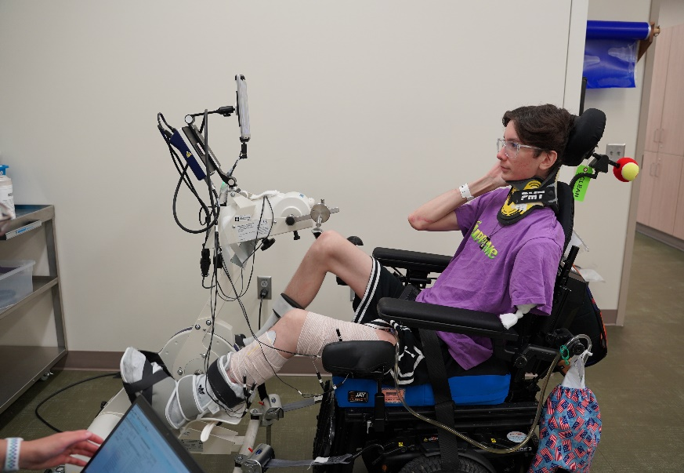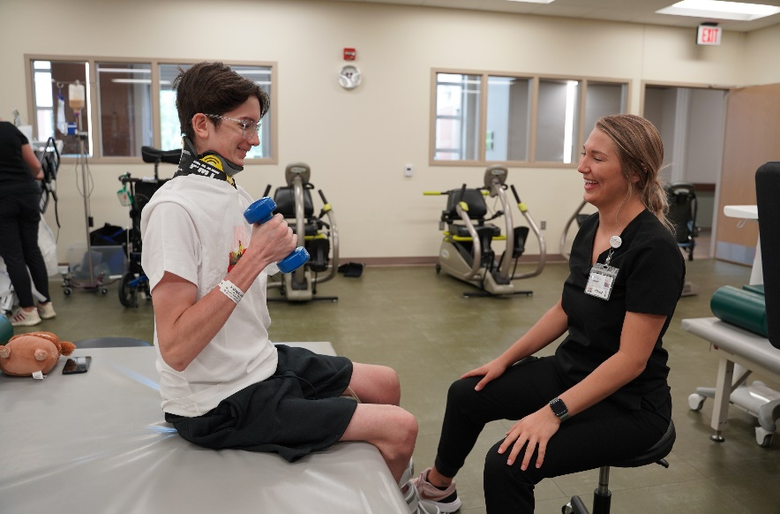

**Jacob Sulzbach**

Jacob is a resilient 19 year old. After completing his first year of college, Jacob worked in construction to gain experience. An unfortunate traumatic accident resulted in him being hospitalized at Mercy in Sioux City.

Jacob suffered many injuries including a left arm amputation, multiple pelvic fractures, compartment syndrome and injuries to his left leg. After several surgeries, Jacob was ready to transition to Madonna LTACH on June 20th. He started therapies. Jacob underwent a skin grafting at Mercy and quickly returned to Madonna.

Jacob has been working hard with therapies. He is seen to the left on the FES bike to strengthen and stimulate his leg muscles. His mom and dad supporting him by his side. We look forward to continuing to work with Jacob in Therapy! More updates to come!