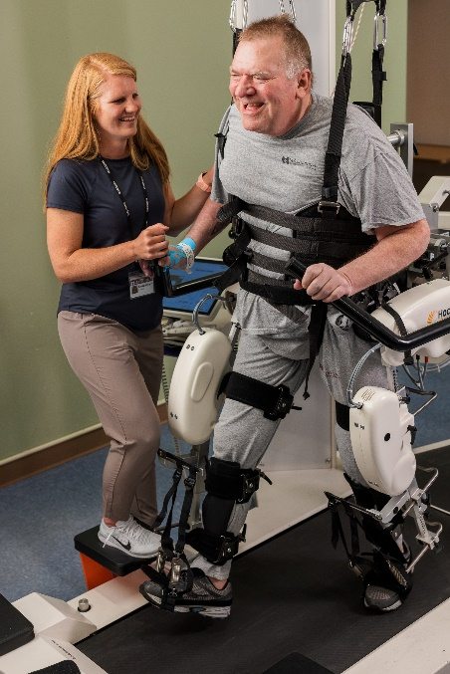

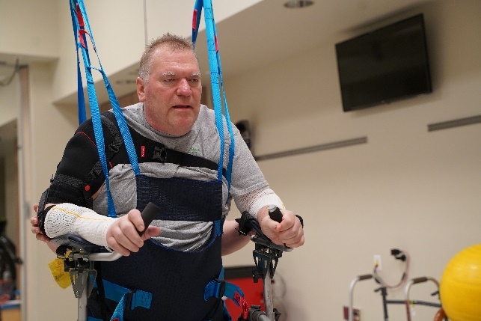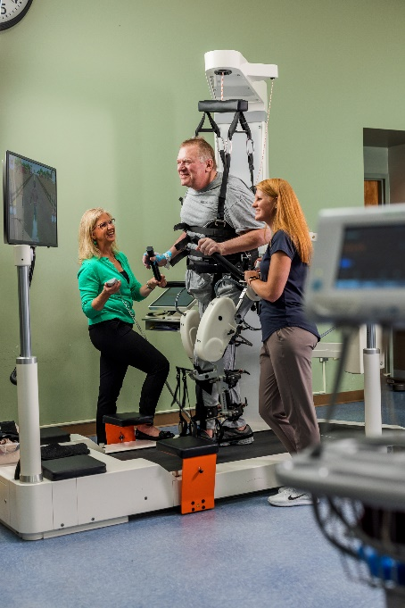 **FRED HUNT**

An update on Fred! Fred is a hardworking, 60 year old male who was at work when he was found unresponsive near his truck. Fred had fallen and suffered a spinal cord injury. He admitted to Avera, where he required surgery to stabilize his neck and a trach for respiratory management.

He has continued to work hard with therapy. They have utilized the Lokomat to get him up and moving! This machine is able to initiate a step pattern or complete the leg movements after they are initiated by Fred. The harness helps keep him stabilized. He is also working on squat-pivot transfers. The Lokomat really got a smile out of Fred!

Occupation therapy has been working on wheelchair mobility in the kitchen, meal preparation, and oven handling. Recreational therapy has just begun, we look forward to what adventures they come up with!

Fred has been working especially hard walking with a walker and using the ICare. He is back in pool therapy and enjoys water walking. Fred continues to work hard to reach his goals!