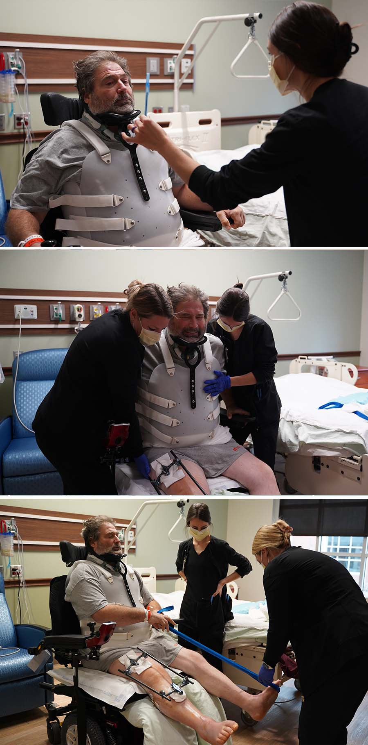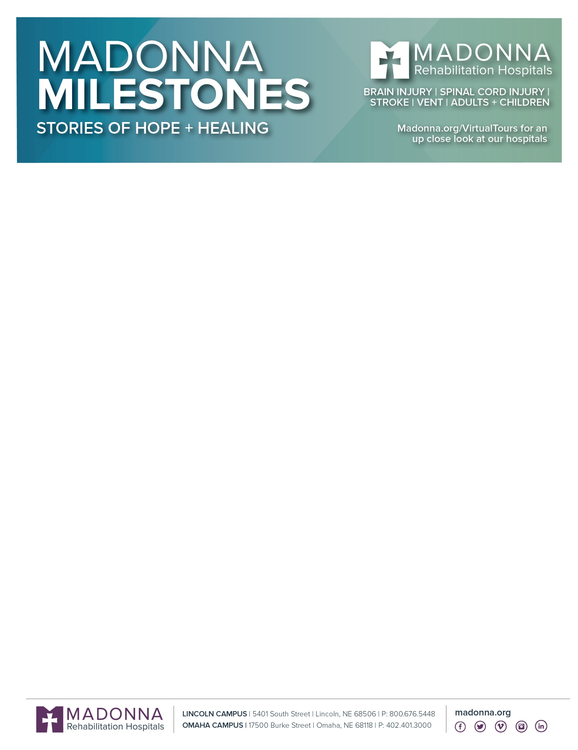

Text Here

**Bill Fuchsen**

Bill Fuchsen is a hardworking Iowa man. Unfortunately, he was involved in a farming accident on October 26th, 2022 which left him with multiple traumatic injuries. He was initially treated at Avera in Sioux Falls. After several surgeries, Bill was ready to move to Madonna on Nov. 11th!

Unsurprisingly, Bill has been working very hard with therapies. He is seen in the first picture to the left, working with Madonna’s vision specialist. He is completing visual scanning activities to promote oculomotor coordination.

In the second picture, Bill is practicing lift-off’s to strengthen his upper extremities- an external fixator won’t stop him! In the last picture, he is using a therapy band to strengthen tight/sore leg muscles and reversing his left foot drop.

With PT, Bill is completing Vander lift transfers to increase lower extremity strength. Bill has been outfitted with a power wheelchair and becoming more independent in the hallways.

With Recreational therapy, Bill has been participating in Group activities, including Christmas Name That Tune to increase peer engagement and socialization. He also enjoys playing Yahtzee.

Bill will return to Avera to have his ex-fix removed and come back to Madonna. Then, he will transition to Acute Rehab in January, 2023! Bills hard work is paying off and we look forward to watching him continue to succeed!